Project Intake Process
Standard Operating Procedures

- On the Department of General Services website, under the Major Projects page, customers (agencies) will be able to access and download a Project Request Form (PDF and Word formats). The form can be found here:
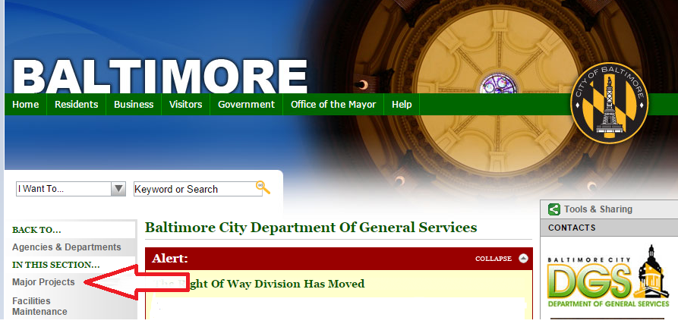

- The customer will be required to fill out the Project Request Form, providing pertinent information including a project description, budget account number, authorization signatures, etc. (all forms without accurate budget number and authorizing signature will be considered incomplete).

- The Project Request form will be submitted by the client agency through the following email: DGSMajorProjects@baltimorecity.gov, which can also be found on the DGS webpage where the Project Request Forms exist. The form will be forwarded to the division chief and the lead program engineer in the Major Projects Division. An automated response will be sent from the Capital Projects email that will inform the requestor that the submission has been received and that it will take two weeks (maximum) to be addressed.

- The form is reviewed for completeness, accuracy, authority, and project classification by the division chief and the lead program engineer in the Major Projects Division.
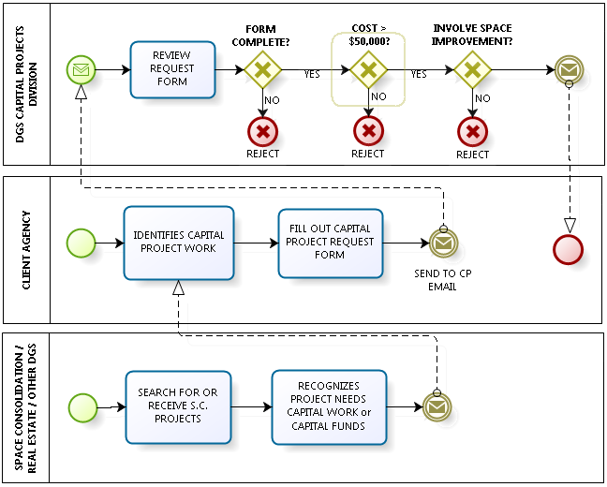

- The form can be rejected for multiple reasons. When the form is rejected, the client agency who submitted the request will be notified that the project request was rejected with an explanation as to why the request cannot be accepted. Reasons that the project request can be rejected are as follows:
  - The form is incomplete (the project description is not detailed enough, no budget account number is provided, a lack of authorization, etc.)
  - The nature of the project does not fit the service criteria of the Major Projects Division. Projects that can be addressed by the Major Projects Division have to exceed a total project cost of $50,000 and the type of work needs to be categorized as facility or space improvement.
It is the responsibility of the client agency to distinguish the type of service that is necessary for the project and address the DGS division that provides the requested service. A sample of the rejection response email is provided below:
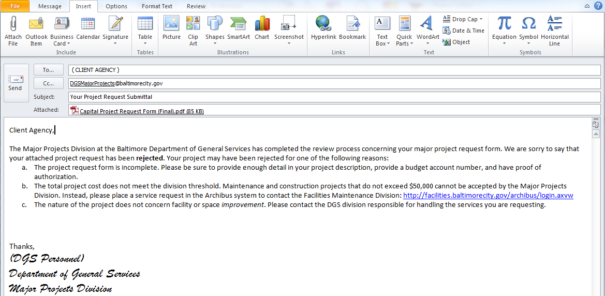

- If the Major Projects Request Form is complete and the nature of the project meets the criteria demands of the division, the Division Chief or the Lead Program Engineer will respond to the client agency with an acceptance email and an initiation of conversation about the accepted project.

- In some cases, staff at the Department of General Services, outside of the Major Projects Division, will discover potential projects or may be contacted by a customer agency directly regarding a project idea and or questions about feasibility. These requests must follow the same procedure and the relevant staff person shall instruct the agency to complete and submit a Project Request Form. (See item #3 above.)

- All staff members within the Major Projects Division are responsible for managing and storing project request forms.

- The Major Projects Division will hold a biannual review meeting to assess the impact and effectiveness of the process. The first meeting will take place Thursday March 31, 2016. The following shall be scheduled and organized by staff in the MPD at the direction of the division chief.

